

Fortna Inc.

West Reading, PA

Ethernet/IP Card Training - Internal Design Document
Document Version: 0.3
Date: 8/24/2015


This page intentionally left blank.
Table of Contents
1 Introduction 1
1.1 Document Objective 1
1.2 References 1
1.3 Document Conventions 1
1.3.1 Standard Definitions 1
1.3.2 Acronyms and Abbreviations 1
1.3.3 Requirements Numbering 1
2 Project Overview 2
2.1 System Layout 2
2.2 High Level Summary 2
3 User Interface 3
3.1 IOCard Menu 3
3.1.1 BasePort 4
3.2 IO Card Init 4
3.3 HMS Card web interface 4
3.3.1 Main 4
3.3.2 Scanlist Config 5
3.3.3 Ethernet statistics 5
3.3.4 CIP Statistics 5
3.4 Allen-Bradley Switch web interface 6
3.4.1 Login 6
3.4.2 Main Page 6
3.4.3 Port To MAC 6
3.4.4 Packet Error Counts 7
3.4.5 QNX Debug Port 7
3.5 Point IO Adapters 8
3.5.1 Firefox 8
3.5.2 Login 9
3.5.3 Main Page 9
3.5.4 Diagnostic Overview Page 9
3.5.5 Ethernet Statistics 10
3.5.6 Browse Chassis 10
3.6 Sixnet Industrial Ethernet Managed Switch 11
3.6.1 Login 11
3.6.2 License Agreement 11
3.6.3 Main Page 11
3.6.4 Port to MAC 11
4 Configuration 12
4.1 Putty Tunnels 12
4.1.1 Single Hop 12
4.1.2 Multiple Hop 12
4.2 HMS Configuration 13
4.3 Update HMS Firmware 13
5 Packet Trace 14

This page intentionally left blank.

Introduction
This Internal Design Document contains the software design details for supporting clients using Ethernet/IP.

Document Objective
The purpose of this document is to serve as a vehicle for supporting clients using Ethernet/IP IO networks.
The intended audience for this document is predominantly the software development team, controls, and customer support.

References
These requirements were gathered through meetings and other communications methods with Client personnel. The final SDR was conducted <location, date> with the following attendance:
Fortna:
Client:
WMS:

Document Conventions

Standard Definitions

Acronyms and Abbreviations
VFD – Variable Frequency Drive

Requirements Numbering

Project Overview
Ethernet/IP IO networks are used to provide IO communication to Point IO devices, VFDs, and Panther Printer Applicators. This document is targeted at supporting existing Ethernet/IP installations and will cover replacing cards and trouble shooting.

System Layout
Ethernet/IP Switch
QNX Automation Controller

HMS Card

QNX Ethernet

Point

Point IO

VFD

Panther Applicator

High Level Summary
Typically the Ethernet/IP network is separate from the rest of the client’s network. The Automation Controller software communicates to the HMS cards to send/receive Ethernet/IP IO. The HMS cards implements the Ethernet/IP stack and acts as an Ethernet/IP client. The Point IO, VFDs, and Panther Applicator act as Ethernet/IP servers. A dedicated second Ethernet card is connected from the QNX Automation Controller to the Ethernet/IP switch for debugging purposes.

User Interface
Provide detailed information for each configuration menu. For instructions on connecting to the Ethernet/IP devices see 4.1

IOCard Menu
The IOCard menu provides the configuration information for interfacing the HMS Card to the Automation Controller Software. Several fields are useful for debugging and configuring the HMS Card. The IOCard menu is located under Configuration Menu … -> IO Utilities … -> IO Card Config.
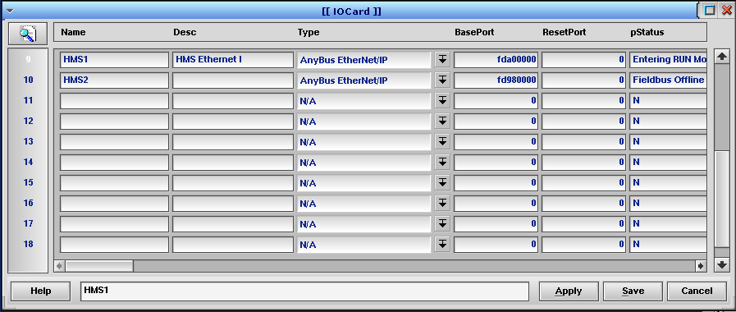

Column | Description
Name | Name of the IOCard configuration. The name must be unique.
Type | Identifies the card as an Ethernet/IP card.
BasePort | Automatically set by the software. Must have a value or the Automation Controller software will not be able to communicate to the card.
pStatus | Status messages.
Process | Should be SORT.
IntAddr | Automatically set by the software. Must have a value or the Automation Controller software will not be able to communicate to the card. This address is the memory mapped address for the card. If the BasePort is valid and the IntAddr is not then the Automation Controller software failed to map the memory.
ConfigMode | 0 – Normal run mode. Card will exchange data. 1 – Card will allow configuration data to be programmed from RsNetWorx or from the web interface.
SerialNumber | Serial number of the card. If this value is incorrect it indicates an issue communicating to the card.
Machine | Must the the current machine or the card will not be processed.
PCIDeviceIndex | Starts at 0 and increments by 1 for each card. The index is the order in which the QNX OS found the card. Replacement cards that are put into the same slot should get the same index. If it is necessary to change the order or position of the cards then card configuration may be reversed.
LogLevel | Controls the level of debug logging.
ABS_IP | The TCP/IP address of the card. Cards on the same network should have unique addresses. This address will be the address of the card’s web page.
ABS_Mask | The netmask of the network. Must be configured.
ABS_DNS1 | Must be configured to make the card work but isn’t used.
ABS_DNS2 | Must be configured to make the card work but isn’t used.
ABS_HostName | Must be configured to make the card work but isn’t used.
ABS_Domain | Must be configured to make the card work but isn’t used.
ABS_UpdateCfg | Y- Automatically update the cards configuration from the saved .cfg file. N – Do not change the card’s configuration.

BasePort
BasePort must match the output from the QNX command “pci –v”. Look for Vendor ID = 10b5h and Device ID = 2889h. Note: Example had reduced text.

Class = Unknown (Unknown)
Vendor ID = 10b5h, PLX Technology, Inc.
Device ID = 2889h, Unknown Unknown
BAR - 0 [Mem] = fdaff000h 32bit length 128 enabled
BAR - 1 [I/O] = ac00h length 128 disabled
BAR - 2 [Mem] = fda00000h 32bit length 524288 enabled

IO Card Init
The IO Card Init menu triggers a function to initialize the card. The Automation Controller software will do an IO Card Init on startup. The IO Card Init should be used if the HMS Card is not responding, if the HMS Card web server can’t be accessed, or if the card configuration has been changed using RsNetWorx. The IO Card Init menu is located under Configuration Menu … -> IO Utilities … -> IO Card Init.

HMS Card – Anybus Ethernet IP Card
2 - Not Used
1 - Not Used
4 - Green – Link
Green/Flash - Activity
3 - Not Used
6 - Green – Connected
Green/Flash – No scan list
Red – Duplicate IP
Red Flash – Connection Timeout
5 - Green – Operational
Green/Flash – Standby
Red - Major Fault
Red Flash – Minor fault

Ethernet Cable Connector

HMS Card – Trouble Shooting
- Verify the I/O Card is being used in the system. Repeat for each I/O Card.
  - IOCard Menu – Look for entries (IOCard – Process) and (IOCard – Machine) are selected. The HMS Card will be listed as “Anybus Ethernet/IP”.
  - Configio – Look for the first entry (Configio – Interface) matches the (IOCard – Desc) and the (Configio – In_Out) is all “0000000000000000”. This is the first Input.
  - Conveyor – Search the (Conveyor – IO_Address_Word) for the matching (Configio – OctalWord). This is the first Input associated with the IOCard. Search for a Phototeye.
  - Ask the client to “flag” the Photoeye.
  - Open the “View IO” screen and verify if the I/O is activated.
- If the Card is in use, check LED’s shown above.
  - In some cases the Automation Controller must be shut down, and the plug removed to reset the card.
  - When the card is powered up – Fortna software is not running. Light 6 should be green (no scan list loaded).
  - When the card is running and the nodes are responding, Light 4, 5, and 6 should be green.
  - If the card has issues with a node (or multiple nodes), Light 6 will be red.
- Verify the connections to the Ethernet Switch or some cases the HMS card is connected directly to an Adapter.
- Verify the connections to the Ethernet Adapter, 1st module in the I/O Rack.
Each Ethernet Cable has a status light

Off – no connection
Green – Connected
Green/Flash – Communication Activity

Ethernet Cable Connector
Ethernet Switch

HMS Card web interface
To access the HMS card interface create a tunnel to the IP Address of the HMS card for port 80.

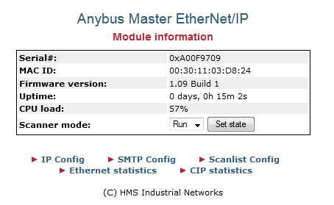
Main
The main page of the HMS Card the following
Firmware version: The firmware version on the card should be at least 1.09 Build 1. Issues reconnecting the Ethernet/IP devices have been seen with earlier versions.
CPU load: A high CPU load can cause loss of IO.
Scanner mode:
- Run – Card will communicate IO.
- Idle – Card configuration can be changed.
The Scanner mode setting can be changed by setting the ConfigMode column in the IOCard menu as follows:
- 0 will put the card into Run mode
- 1 will put the card into Idle mode

Scanlist Config
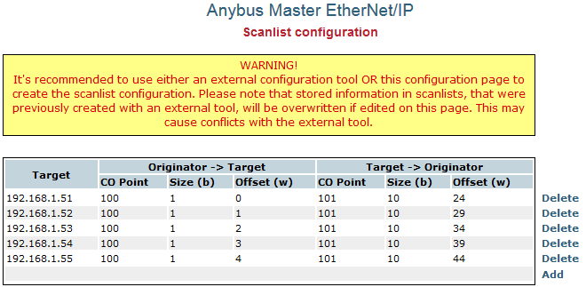
The Scanlist Config link can provide the IP addresses of all the Ethernet/IP modules accessed by the card. If 2 cards are present then each card will control only its own devices.
Note: The HMS Card contains a bug requiring the Scanlist Config to be deleted in the web interface before reprogramming the card. When replacing a card it is required to place the card in Idle mode and Delete each Target in the Scanlist Config.

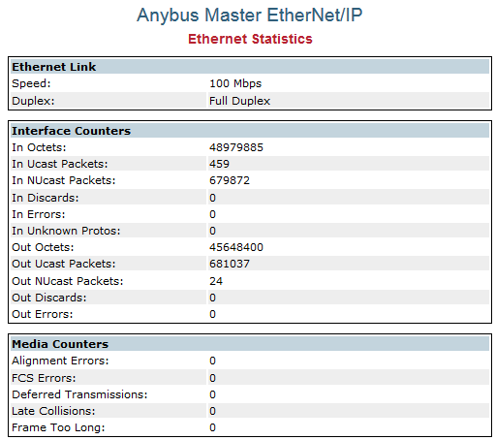
Ethernet statistics
The Ethernet statistics link can show connection issue with the HMS Card. The Speed should be 100 Mbps and the Duplex should be set to Full Duplex. The Alignment Errors and FCS Error can show issues with the physical network.

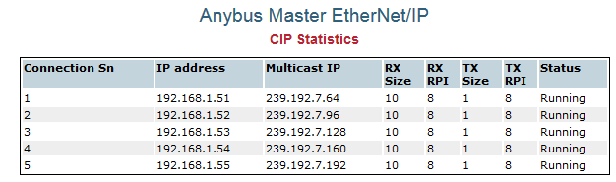
CIP Statistics
The CIP Statistics can show the status of individual modules. The Status should be “Running”.

Allen-Bradley Switch web interface

Login
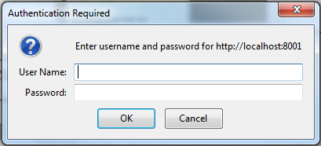
The 1734-EMS08T/A Ethernet/IP switch has a default login as
User Name: <leave blank>
Password: PASSWORD (case sensitive)

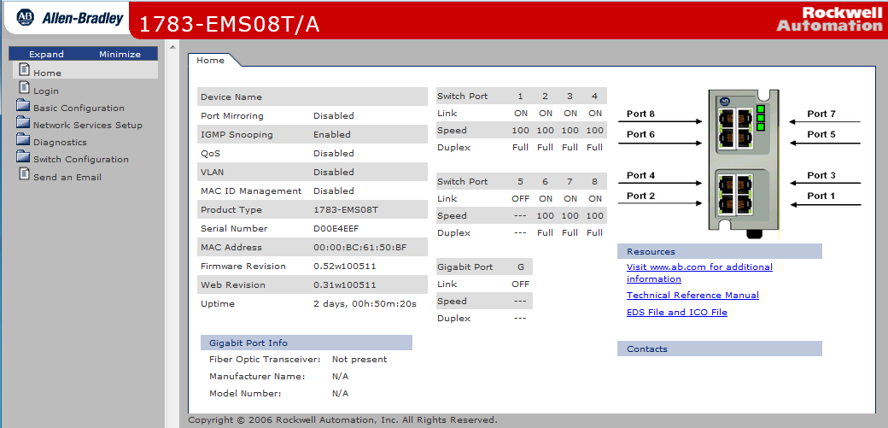
Main Page
The Home web page for the switch provides information about the connected state of the switch.

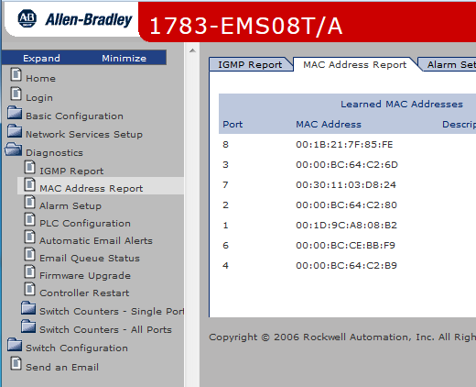

Port To MAC
Selecting the Diagnostics option provides access to the MAC Address Report (shown in the image at right). This can be used to determine what device is connected to which port. The IP Address to MAC addresses can be found by pinging each IP Address and running ‘arp –an’ on the QNX box.

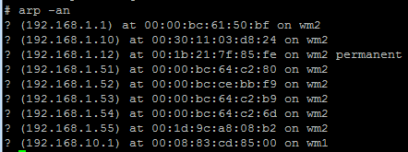

Rx Symbol Errors

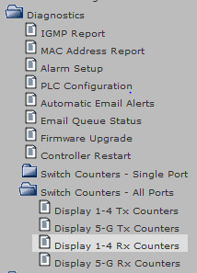
Packet Error Counts
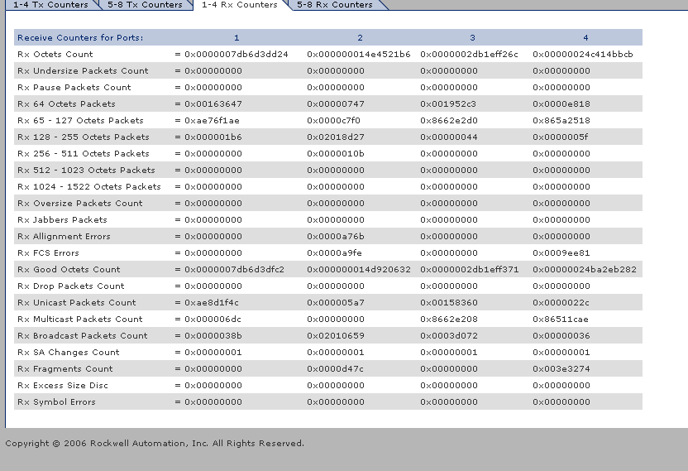
The Ethernet/IP switch keeps a count of the number of packets received and the errors on each port. The counts are listed under Diagnostics -> Switch Counters – All Ports. To determine the % error rate the number of error packets over time period should counted and divided by the total number of packets. The 1734-EMS08T/A provides the packet counts in hex and the total packet count must be calculated by adding the packets of different sizes. I recommend using an Excel spreadsheet. The EthernetIP_ErrorRate.xls file at https://redmine.fortna.com/documents/206 can be used. The errors are entered in hex with no preceding 0x.

QNX Debug Port
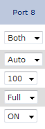
The QNX Debug Ethernet connection will not default to full duplex unless Negotiation is set to Auto. To find the port the QNX Debug Ethernet connection is on use ifconfig to find the MAC address.
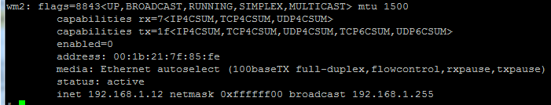
The port number can then be determined from the Diagnostics->MAC Address Report.

Point IO Adapters
The Allen-Bradley Adapters for the Point IO modules have debug web pages. The modules use Java so Java must be enabled in your web browser,

Firefox
Install the most recent Java 7 SE from
http://www.oracle.com/technetwork/java/javase/downloads/index.html
Select the menu Firefox -> Add-ons. Click the Plugins tab 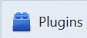
For the Java plugin select Ask to Activate

For each web address Java needs to be granted an exception.
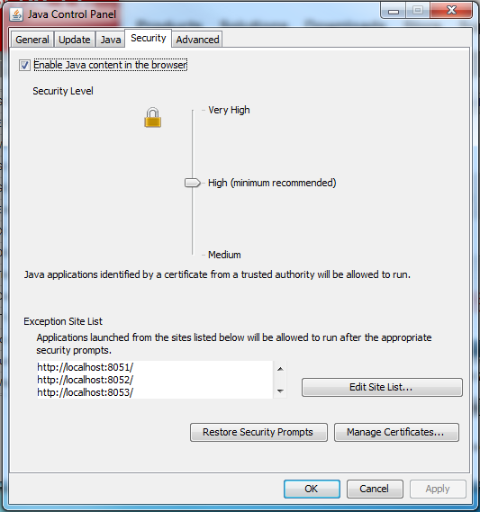
From the Start menu  select All Programs -> Java -> Configure Java.
Click the Security tab.
Click Enable Java content in the browser.
Set the Security Level to High.

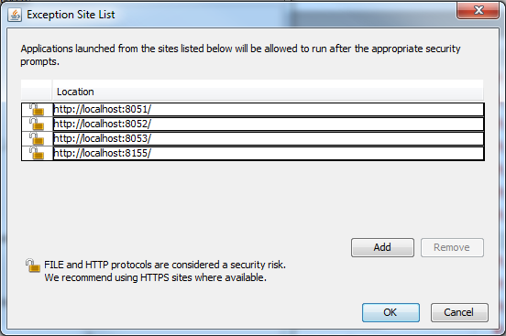
Click Edit Site List …
Click Add.
Add each url to allow Java to run.
http://localhost:<port>/
note: if directly connected use
http://<ipaddress>

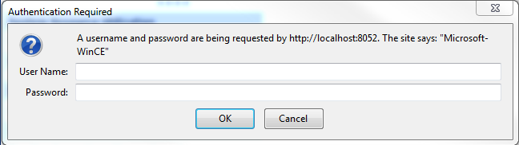
Login
The default User Name is admin.
The default Password is password.
Both are case sensitive.

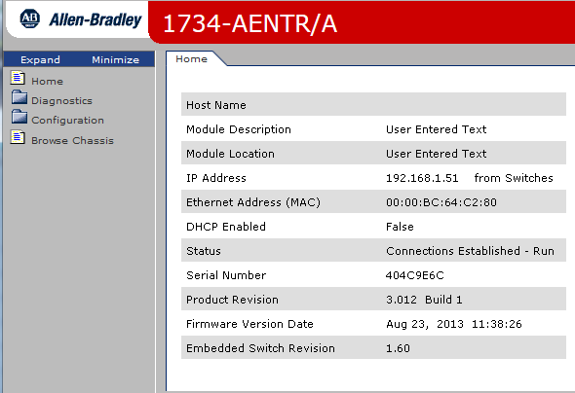
Main Page
The main page provide information about the Status of the connection to the HMS card, the MAC address, and the firmware version.

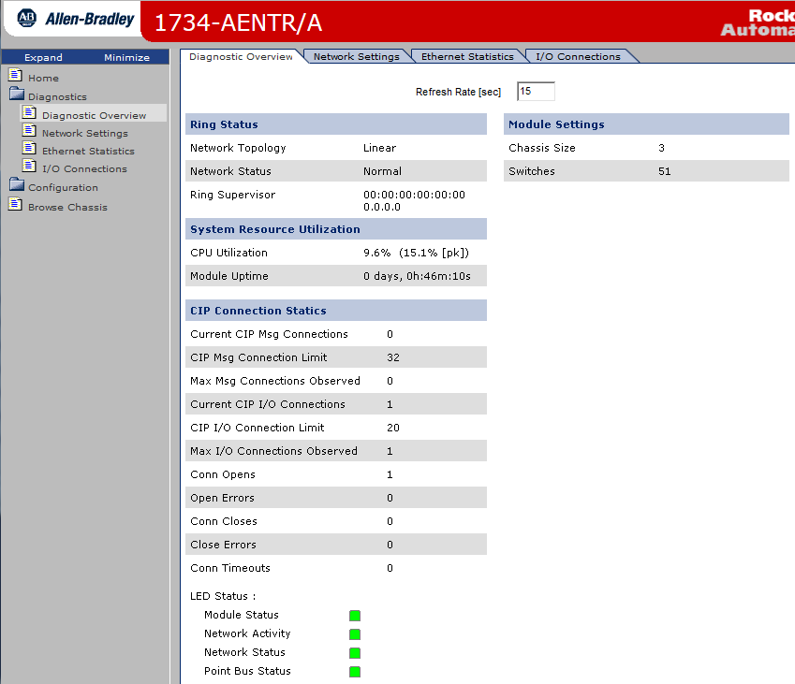
Diagnostic Overview Page
Provides CPU Utilitization, Uptime, and Open Errors.

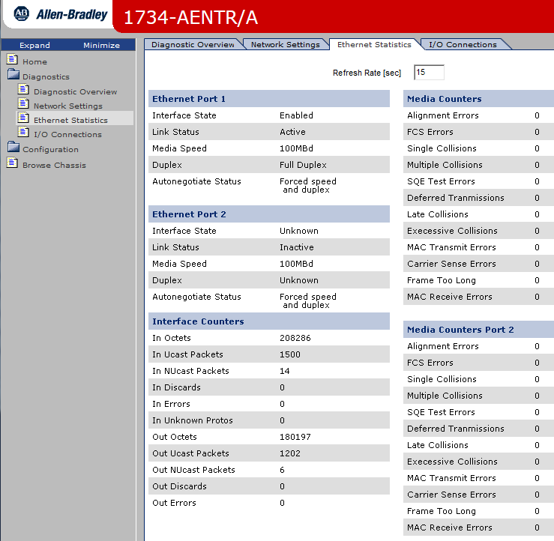
Ethernet Statistics
Media Speed should be set to 100MBd, Duplex should be set to Full Duplex. Excessive Alignment Errors and FCS Errors can indicate problems with the network infrastructure.

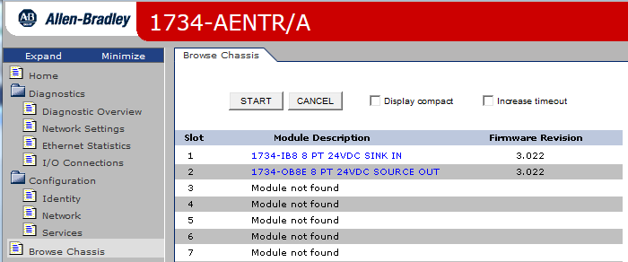
Browse Chassis
Click the Browse Chassis link. Under the Browse Chassis tab click Start. All the modules connected to the Adapter will be displayed.

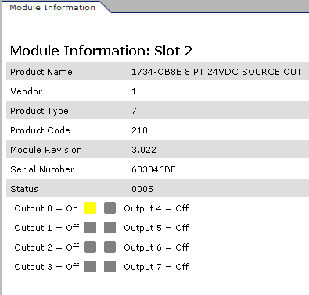
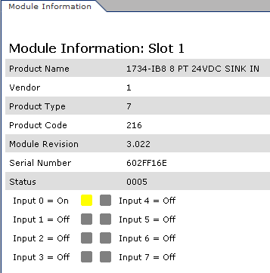
Clicking Module Description link will provide information about the module. The input/output status of the module can be displayed. Refreshing the browser is necessary to update the IO Status.

Sixnet Industrial Ethernet Managed Switch

Login
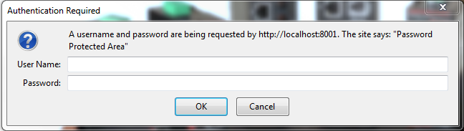
The default username is admin and the password is admin for the Sixnet Ethernet/IP switch. You need to allow the popup to get to the next screen.

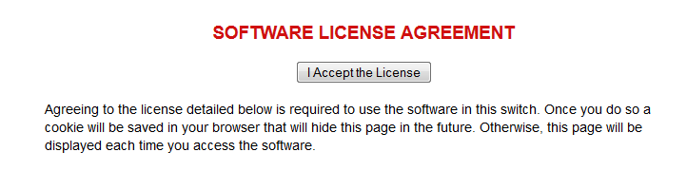
License Agreement

You need to Click “I Accept the License” to access the switch.
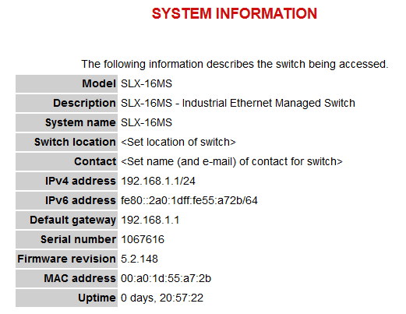

Main Page
The main page provide basic information about the Model, IP address, MAC Address, and firmware version.

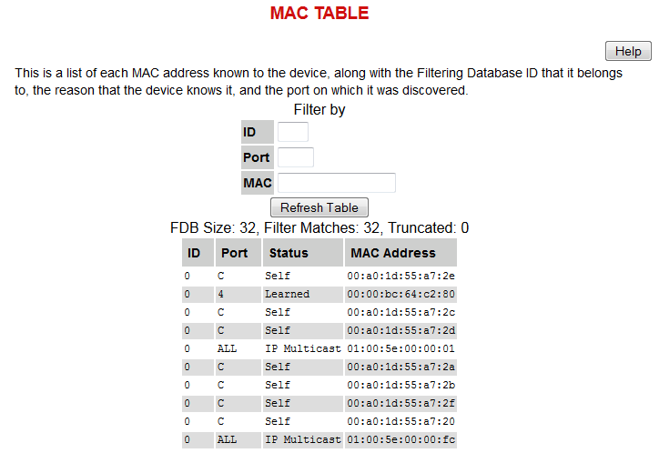

Port to MAC
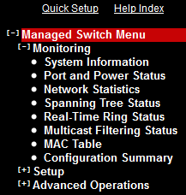
Find the port for a MAC Address click Managed Switch Menu -> Monitoring -> MAC Table.

Configuration
This section is focused on installing a new HMS Card using an existing backup directory. It is assumed the machine is installed with QNX and the HMS card(s) are installed.

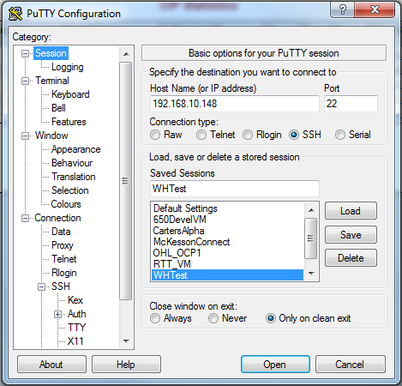
Putty Tunnels
The Ethernet/IP network is typically on a separate Ethernet network. In order to access the Ethernet/IP devices tunnels need to be created through the Automation Controller.
Create a putty configuration to the Automation Controller.

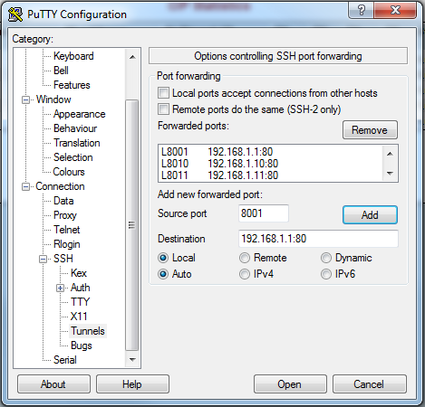
Single Hop
Under Connection -> SSH -> Tunnels for Source port pick an unused local port. I typically pick 8001 for address 192.168.1.1:80, port 8010 for address 192.168.1.10:80.
Under destination use the IP address of the Ethernet/IP device and click Add.
This can also be done after a connection is made by right clicking the title bar and selecting change settings …

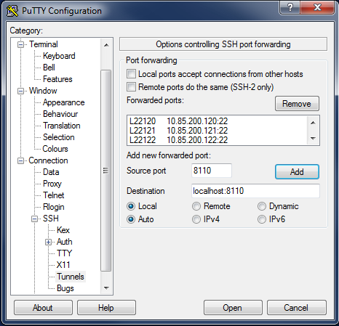
Multiple Hop
If tunneling through a Level 2 system is required a multiple hop tunnel is necessary. Configure the source port to an unused local port, however the destination address will be localhost:<port number>.
Connect to the Level 2 system and ssh to the Automation Controller with
ssh root@<controller ip> -L<port>:<eip ip>:80
example: Carters CARUSS
ssh root@10.85.200.127 -L8110:192.168.1.10:80

HMS Configuration
Cards that come from stock or other machines should have their configurations deleted. Initialize the card by starting the Automation Controller software from the client’s backup. Go to the IOCard menu and lookup the IP address of the card(s) see 3.1.
Put the card into Idle mode by setting the IOCard menu ConfigMode column to 1.
Go to the card’s web page using the card’s IP address. Under the Scanlist config link delete all the targets see 3.3.2.
Validate the IOCard menu ABS_UpdateCfg column is set to Y. Put the card back into Run mode by setting the IOCard menu ConfigMode column to 0.
Run IO Card Init see 3.2.
Validate the configuration updated by viewing the Scanlist config web page on the HMS card.

Update HMS Firmware
HMS Cards from stock have old firmware versions. To update the HMS card’s firmware get the latest firmware from
sftp://swftp@ftp4.fortna.com/home/swftp/ftpdata/JobsArchive/Rel10/Utilities/7181_1_09_01.hms
Copy the firmware to the Automation Controller into a directory of your choice, preferably “/TARS”.
Open a terminal window on the Automation Controller and navigate to the directory where the firmware was copied. FTP the file to the HMS Card. Use “root” as the username with no password. Set transfer mode to binary with the command “bin”. Upload the firmware to the HMS card with the command “put <filename>”. Run IO Card Init and wait 2 minutes for firmware to update. Validate firmware version on the HMS Card webpage.

Packet Trace
Tracing packets can be done using the tcpdump command.
tcpdump –i <interface> -p -s 0 –w <trace file> –C <file size> -W <# of files> port 44818 or port 2222
example:
tcpdump –i wm2 –p –s 0 –w packettrace.pcap –C 1M –W 10 port 44818 or port 2222
This will create 10 1 Meg packet traces that loop.

